

Capstone Project - Strut

Group 6

Assignment 3

Members

- Moegamat Tashreeq Waggie – 100 %

- Jamie Lee Van Der Berg – 100 %
- Khuliso Sikhwivhilu – 100 %
- Areeb Royeppen – 100 %

- Dean Ockhuizen – 100 %
- Dahraan Abrahams – 100 %

- Moegamat Ismaeel Ed'rees Jefferies – 100 %

Human Computer Interaction

Standard Tasks

Student

Once they have signed the consent form and logged in

- Directions/Paths (main task) –User will be taken to the home page where they will have the option to click on the ‘Get Directions’ button. They will be taken to a screen that will ask the user to enter their current location and destination.

The ‘Find’ will prompt the user to another screen that will display a map with the path. The user will have the option to view detailed directions at the bottom of the screen.

- Timetable view and directions – User will be taken to the home page where they will have the option to click on the ‘Time Table’ button. They will be taken to a screen that will allow the user to view their timetable. They will be prompted to get directions to a specific period form this screen. They will have to tap on a period on the timetable. This action will take them to another screen that will display a map with the path. The user will have the option to view detailed directions at the bottom of the screen.

- Exam timetable view and directions - User will be taken to the home page where they will have the option to click on the ‘Exam Time Table’ button. They will be taken to a screen that will allow the user to view their exam time table. They will be prompted to get directions to a specific period form this screen. They will have to tap on a venue on the exam time table. This action will take them to another screen that will display a map with the path. The user will have the option to view detailed directions at the bottom of the screen.

- Venue Booking - User will be taken to the home page where they will have the option to click on the ‘Book Venue’ button. They will be taken to a screen that will ask the user to enter the venue, date and timeslot(period). The screen will have a button ‘Check Availability ’to allow the user to check availability of a venue and another button below it ‘Book Venue’ to book that venue that has been checked.

Visitor

- Directions (main task) - Once the user has entered the mobile application they will be prompted to an options screen where they choose that they either a student or visitor. Once they have chosen visitor they will be prompted to another screen. They will be taken to a screen that will ask the user to enter their current location and destination. The ‘Find’ will prompt the user to another screen that will display a map with the path. The user will have the option to view detailed directions at the bottom of the screen.

Informed Consent

Strut

We are students at the University of the Western Cape, in the Department of Computer Science. We are conducting a study, which you are invited to take part in. This form has important information about the reason for doing this study, what we will ask you to do if you decide to be in this study, and the way we would like to use information about you if you choose to be in the study.

Why are you doing this study?

You are being asked to participate in a research study about our new navigation mobile application called Strut where you will be interacting with various prototypes of the mobile application. The purpose of the study is to see whether the new student navigation mobile application will make the current method of find venues more efficient, enjoyable and decrease the stress of student allowing them to find lecture and exam venues easier.

What will I do if I choose to be in this study?

You will be asked to interact and use our Strut mobile application and have a short interview/fill out questionnaire. The whole study should take approximately 15 to 20 minutes. The study will be conducted in the Sun Lab in the CAMS building. During the interview we would like to audio-record, video-record and/or screen record this interview to make sure that we remember accurately all the information you provide. We will keep these recordings in a safe place, and they will only be used by the Strut team. If you prefer not to be audio-recorded, we will take notes instead.

How will you protect the information you collect about me, and how will that information be shared?

Results of this study may be used in presentations. Your study data will be handled as confidentially as possible. If results of this study are to be presented, individual names and other personally identifiable information will not be used. To minimize the risks to confidentiality, we will limit the access to the data as much as possible , if we share the data that we collect about you, we will remove any information that could identify you before we share it this includes all video recordings if taken. If we think that you intend to harm yourself or others, we will notify the appropriate people with this information.

Who can I contact if I have questions or concerns about this research study?

If you have questions, you are free to ask them now or you may contact the researchers at MobileStrut@gmail.com, there will be a quick and efficient response.
CONSENT FORM

Title of Project: [Strut]

Name of Researcher: [Moegamat Tashreeq Waggie, Jamie Lee Van Der Berg, Khuliso Sikhwivhilu, Dahraan Abrahams, Areeb Royeppen, Dean Ockhuizen, Moegamat Ismaeel Ed'rees Jefferies ]

Please initial all

boxes

- I confirm that I have read and understand the information sheet dated [09/10/2019] (version [1.0]) for the above study. I have had the opportunity to consider the information, ask questions and have had these answered satisfactorily.

- I understand that my participation is voluntary and that I am free to withdraw at any time without giving any reason, without my medical care or legal rights being affected.

- I understand that relevant sections of my medical notes and data collected during the study, may be looked at by individuals from [Strut team and lectures], from regulatory authorities or from the NHS Trust, where it is relevant to my taking part in this research. I give permission for these individuals to have access to my records.

4. I agree to my GP being informed of my participation in the study.

5. I agree to take part in the above study.

Name of Participant Date Signature

Name of Person Date Signature
taking consent.

User Interviews
Link to video and Consent form -
https://drive.google.com/drive/folders/1rS16W57fR3Q9o0BBhedp4roTq6exqhy
C?usp=sharing

User 1

Name: Sidrah Palekar

Occupation: BSc (3rd year)

Gender: Female

Test description

The test was conducted in the Sunlab in the CAMS building on the 9th of October 2019.

The user interacted with the prototype on an Android device.

Task

The user was requested to take on the role of a student.

The user was then asked to log in and thereafter navigate through the application.

Method

We explained the purpose of the application to the user and gave no further instruction.

The purpose of this was to gauge the usability and level of intuition the interface exhibits.

An interview was held post-experiment to understand why the user struggled with certain tasks and then enquire what changes would make the experience more friendly to the user.

Feedback

- The design of the system was simple and straightforward.

- On the timetable view where users can click on venues to navigate there; the user did not know they could click on them. The user suggested a hyperlink style display to let users know it is clickable.

- The user tried swiping on most screens but was unable to explain why that was.

- The user was keen on having the sections of the timetable that are clickable resemble buttons.

- The user clicked on the User icon on the home screen thinking it would display information not prompt them to log out.

Link to video and Consent form -

https://drive.google.com/drive/folders/14eAORJlnnlEGXGolCp2Mc3g3Qk8G8BC
Q?usp=sharing
User 2

Name: Aatiqah Collins
Occupation: BSc (3rd year)
Gender: Female

Test description
The test was conducted at my house on the afternoon of the 9th of October 2019.
The user interacted with the prototype via the browser on a laptop.

Task

The user used the application as a student would, to find venues at the university and possibly book venues or view their timetable.

Method

I explained to the user what the application is and its purpose. She then proceeded to use to application, while providing feedback at the same time.

Feedback

1 The name was not clear and left user confused as to the name of the app.

- The path displayed for the user to navigate to a building required more detail and needed start and end points to make it clear where a user is starting.

- The map displaying the path should have more clarity
- The user did not find the short instructing for walking helpful

- The user liked the timetable functionality

- The user was concerned with timetable changes which happens often for her course

- The user suggests that we add the ability for a user to add notes to their exam timetable.

- The user did not like the colour scheme of the application, as she found it too colourful.

- The user is confused by the venue booking interface.

- The user wants buildings on the path map to be clearly labelled.

Link to video and Consent form -
https://drive.google.com/drive/folders/1S6EoSpa4gGGkF1MlWov80SBpvu05ow
Zq?usp=sharing

User 3

Name: Anathi Hlaula
Occupation: BCom (3rd year)
Gender: Female

Test description
The test was conducted on campus in the CAMS Building.
The user interacted with the prototype via the browser on a smartphone.

Task

The user used the application as a student would, to find venues at the university and possibly book venues or view their timetable.

Method

I explained to the user what the application is and its purpose. She then proceeded to use to application, while providing feedback at the same time.

Feedback

- The written directions from and to a building were vague and were to simple. They need to be more precise.

- The application should allow the student to manipulate the timetable beyond academic activities. It should allow the user to change and insert activities at will.

- The application should help the user to navigate to and book for an appointment with medical assistance on campus grounds.

- The application should alert or notify user of any personal events.

- The application should allow students to record their marks.

Field Study

In order to conduct our field study, we would have students use a mobile device (smartphone) pre-installed with Strut (our app) along with a screen recorder to measure the time it takes the student to understand the outline of all in-app functions.

We will have the students complete the following tasks:

- Get directions to venue

- View timetable

- Get directions from timetable

- View Exam Timetable

- Book an available venue

To avoid any bias being introduced into the study, we will refrain from recording the user’s facial expressions as a form of data collection as this results in users changing their outlook and actions. Thus, losing focus of the tasks at hand which affects data collection.

At the end of each separate student user study, the student will be given a short survey in order to query their frustrations or difficulties faced while completing in-app tasks.

The following needs to be accounted for:

- Students familiarity with the campus

- Students familiarity with Android/Apple iOS interface

- Students have different courses

- Students are from different year groupings (1st year, 2nd year, etc.)

The following types of data will be collected:

- Average time spent completing in-app tasks

- Time spent actually completing each task separately (Refer to tasks above)

- Ease-of-use

- Data collected from the survey after engaging with the app

Data analysis:

- Line Graph used to reflect patterns in Student vs average time for all tasks completed

- Pie chart indicative of average time taken to complete each individual task (e.g. average time taken to get directions to venue across all students in field study)

- Statistics: Mean, Median, Mode for task taken longest to complete in field study

- Analyze screen recordings and identify patterns in student interaction with the app
Controlled Study

Benefits

- Controlled research is a research conducted in a setting specifically designed for research. This produces quantifiable data tightly linked to the participants’ usage of the application.

- Due to the greater control that researchers are generally able to exert in a controlled setting than in a naturalistic setting, controlled research studies are more likely to represent a true experimental design of the application.

- Controlled studies have the advantage of greater control of irrelevant variables that might otherwise influence the results and thus possess clearer clues of the behaviours being observed when using the application.

- This approach comes close to establishing a cause-and-effect relationship which increases understanding of the behaviours of the subjects when using the application. This can produce data which clearly highlights specific areas of performance of the application.

- Another advantage of controlled research is its reproducibility. The environmental conditions can be neatly controlled and documented.

Problems

- The subjects in controlled research usually know that they are participating in a research study, which could bias their behaviours and hence the validity of the data linked to their observed behaviours and patterns when using the application.

- It may represent an artificial environment that may also influence the manner in which subjects behave and therefore alter results.

- Maximizing the internal validity of the observed data linked to the subjects using the application requires very rigid control in a controlled setting, which in turn makes the research less realistic to a non-controlled setting.
Field/Natural Study

Benefits

- Field research is a research conducted in the real world or a natural setting. It tends to observe, analyse, and describe what exists rather than manipulating a factor under study. The research settings resemble the situations encountered in daily living, preserving the naturalness of the usage of the application.

- Participants in a field research may or may not know that they are being studied which reduces behavioural bias when using the application.

- The principal advantage of field research is its generalizability to real-life contexts because they represent a greater variety of situations and environments that subjects experience in their natural settings.

Problems

- The lack of control and the impossibility of precisely characterizing the field environment may make it very difficult to judge the generalizability of the observed behaviours of the participants when using the application and how it links to improvements to be made to the application.

- The more natural the experimental setting becomes, the more difficult it becomes to control extraneous variables.

Conclusion

The most fruitful overall research approach is usually to use both, controlled and field research. The results of controlled experiments produce new approaches or hypotheses to be tried and investigated in the field. Conversely, observations in the field produce new hypotheses to be tested by controlled experiments.

- Hassan A. Aziz, Archives of Clinical and Biomedical Research, Volume 1, Issue 2, 28 April 2017
Databases

Entities

- Student

- Enrolment º Module º Timetable º Venue

º Building

º ExamTimetable

- BookedVenue

Business Rules

1 Student has M Enrolments; possibly none
1 Enrolment belongs to 1 student; not none

1 Module has M Enrolments; possibly none
1 Enrolment belongs to 1 Module; not none

1 Module is found in M Timetables; possibly none
1 Timetable contains 1 Module; not none

1 Venue is found in M Timetables; possibly none

1 Timetable contains 1 Venue; not none

1 Module is found in M Timetables; possibly none
1 Timetable contains 1 Module; not none

1 Venue is found in M ExamTimetables; possibly none
1 ExamTimetable contains 1 Venue; not none

1 Building has M Venue; possibly none
1 Venue belongs to 1 Building; not none

1 Student has M BookedVenues; possibly none

1 BookedVenue belongs to 1 Student; not none

1 Venue has M BookedVenues; possibly none
1 BookedVenue contains 1 Venue; not none

Entity Relationship Diagram
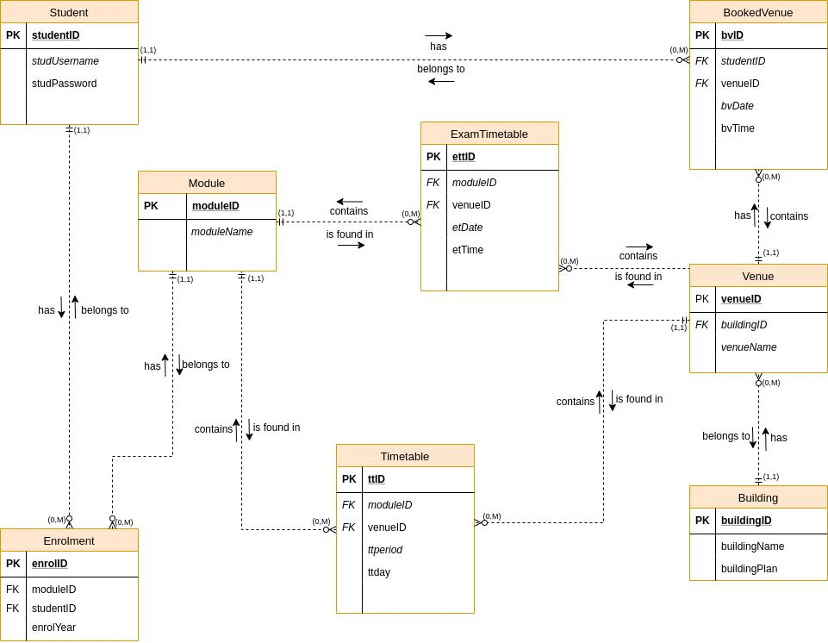

Software Engineering

General Principles

- Abstraction

The user will only be shown digestible information rather than technical details which is hard to understand.

- Localization

The app will only display to the user information which is relevant to their current location query.

- Hiding

The user will not be shown the background workings of the application, they will only be presented with the results of the background activities which will help navigate them towards their destination.

- Completeness

The application will fulfil all the user requirements, which in this case is providing sufficient information to users so that they may reach their requested destination.

Goals

- Understandability

The application will be easy to use, and users will be able to quickly identify how to use the application. When users use the application for the first time, we plan to construct and implement a walkthrough which will take a user through steps of how to use the application.

- Reliability

The application will be reliable to use without losing any of its functionality or crashing at random times leaving users unable to use it.

- Security

Users who are not visitors will always need to be logged in with their own login details in order to utilize the application so that other users may not have access to their details and information. The data we store in the database will not be available to unauthorized persons, this is so that user’s data that we store remains safe and unavailable to unauthorized and/or third parties with malicious intent.

Umbrella Activities

- Software project tracking and control

Tracking the progression of the project is key given the short amount of time at hand to complete tedious and complex tasks. Our team is using Agile Scrum Methodology which best suits for the short time and uncertain timetables of our team members. Having daily sprints of various time frames will allow the team to keep track of accomplished tasks to date.

- Software Quality Assurance

Making sure the software meets the functional requirements of the project. Given that the system is to work on a daily basis, careful consideration will be put into building the application to cope with daily operation. The application will also be built with familiarity to presently operating navigating systems to ensure that the system is usable.

- Technical Reviews

Examining the suitability of the application for daily navigational use and identifying any discrepancies from specifications and standards. Reviews gathered from testing. Testers will include Developer, Students and Visitors.

Technical Reviews will be gathered from student’s initial full interaction with the application, to iron out any inconsistency that may occur.

- Software Configuration Management

Software Configuration will be occurring every 2 months to update the paths recorded after the use of the app for those 2 months by students and visitors that will be using the application. Updates to the paths will include new shortest paths to and from buildings, and possible new spots that students and visitors go to frequently.

Student timetables will need to be part of the software configuration. This accommodates for new modules that students will need to do in new terms, semesters or years. To support the app’s exam notification functionality, the data from student’s modules will be used to draw up an exam timetable personalized exactly for the student.

- Reusability Management

Some of the functionality of the software was reused and was made possible via Google’s Map API’s, since google maps is able to locate paths and paths to buildings.

Module data from students from a certain year with similar or same modules as newer students will be used to now personalize new student’s academic timetables.
